Approving Salaried Leave Time

If an approver finds an error, the timesheet should be returned to the employee for correction. Once corrected, the employee should resubmit the report to their supervisor for approval.

Go to Davidson’s secured website: Banner Self Service

Enter User ID and Pin, and then click ‘Login’. Pin numbers can be obtained and/or re-set by the ITS Help Desk.)
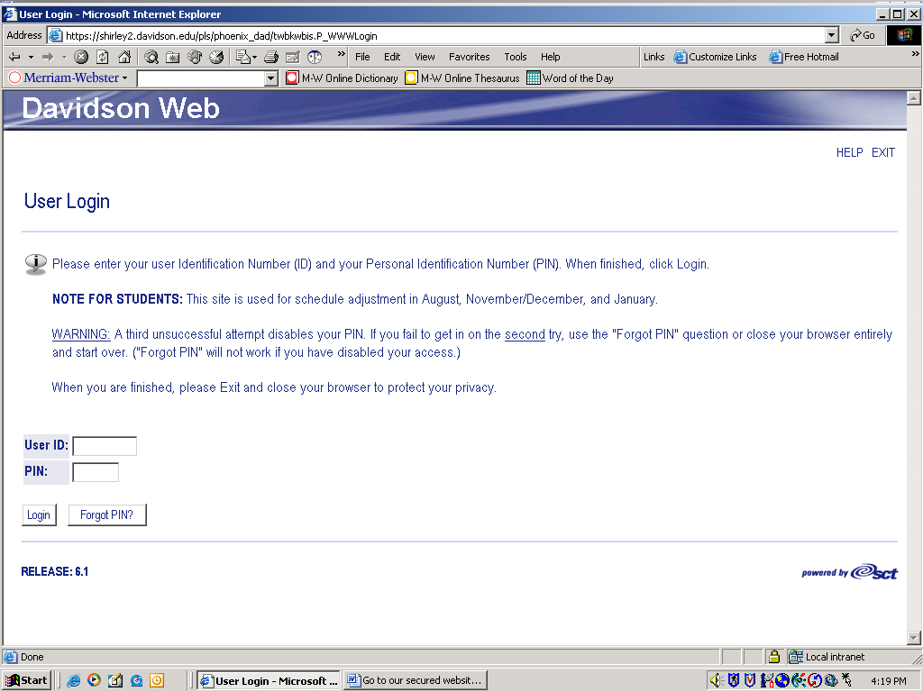

Click Employee Services.
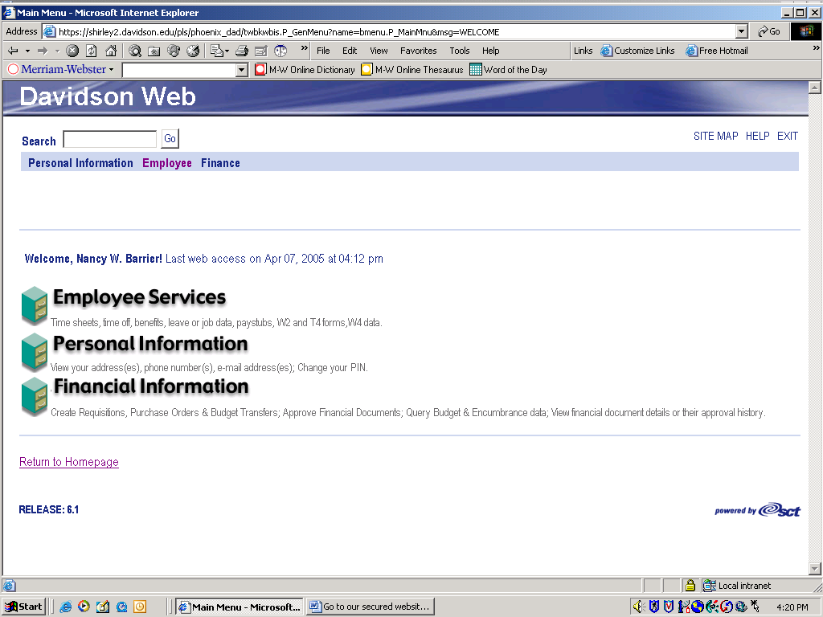

Click Enter or Approve Time-Salaried Employees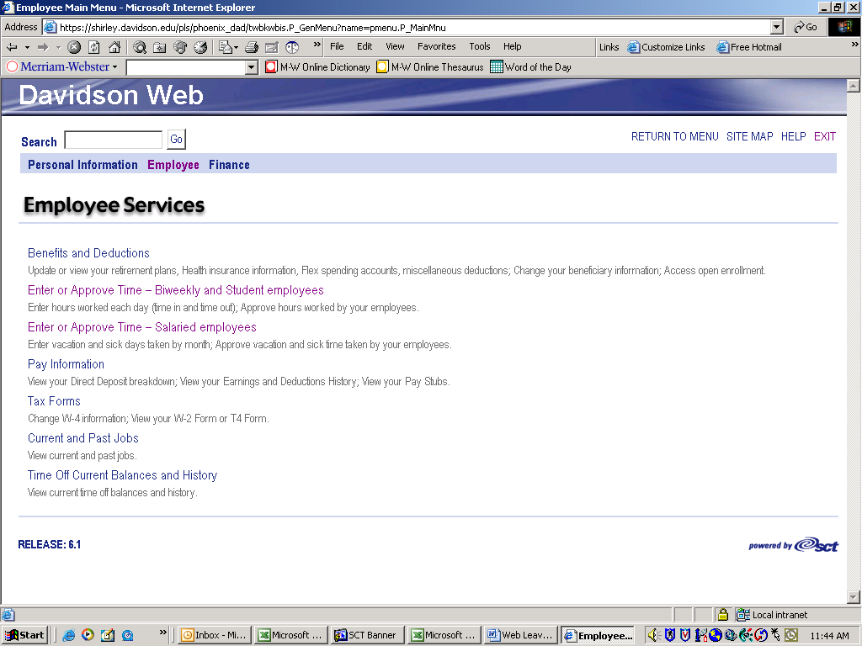

At the Time Sheet Selection Criteria screen, click Approve or Acknowledge Time, and then Select.
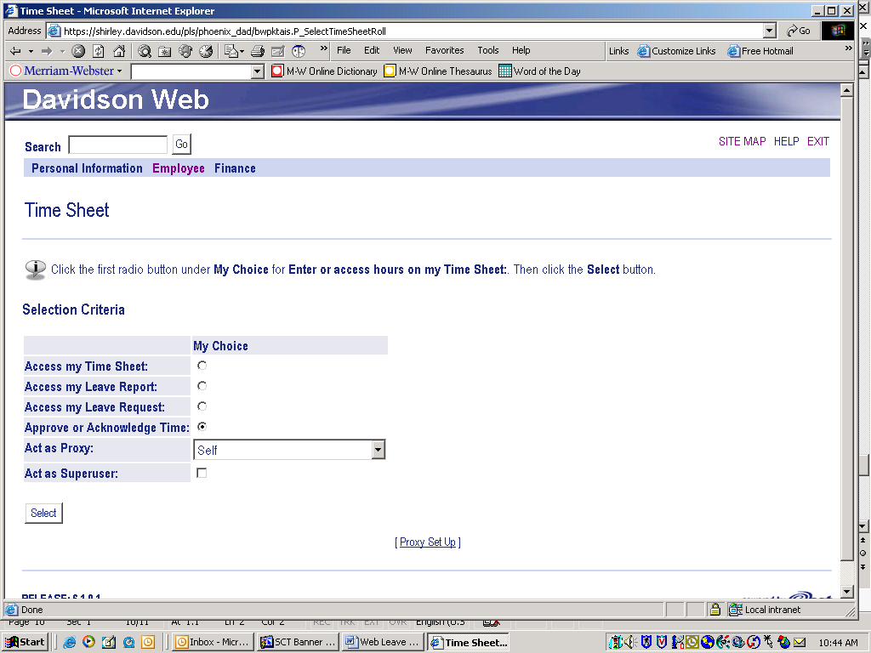

Select the appropriate group and time period. Click Select
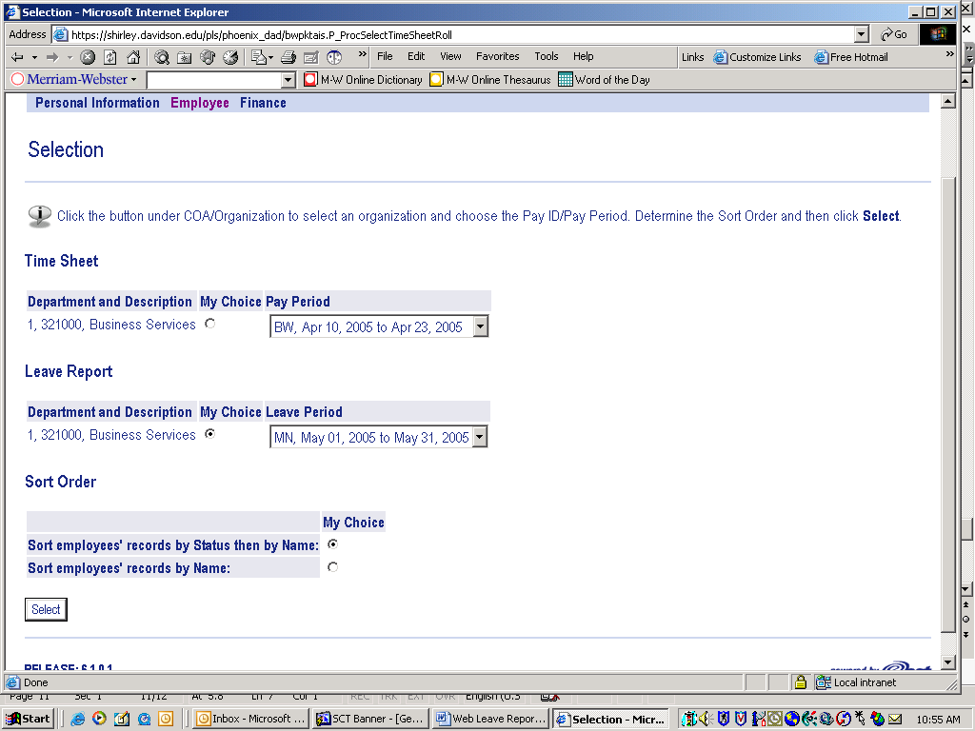

The supervisor has the ability to approve time taken for all employees from the Summary screen. Click the Select All, Approve or FYI button, and then Save. To view the detail by day and any comments made prior to approving the time, click the employee’s name.

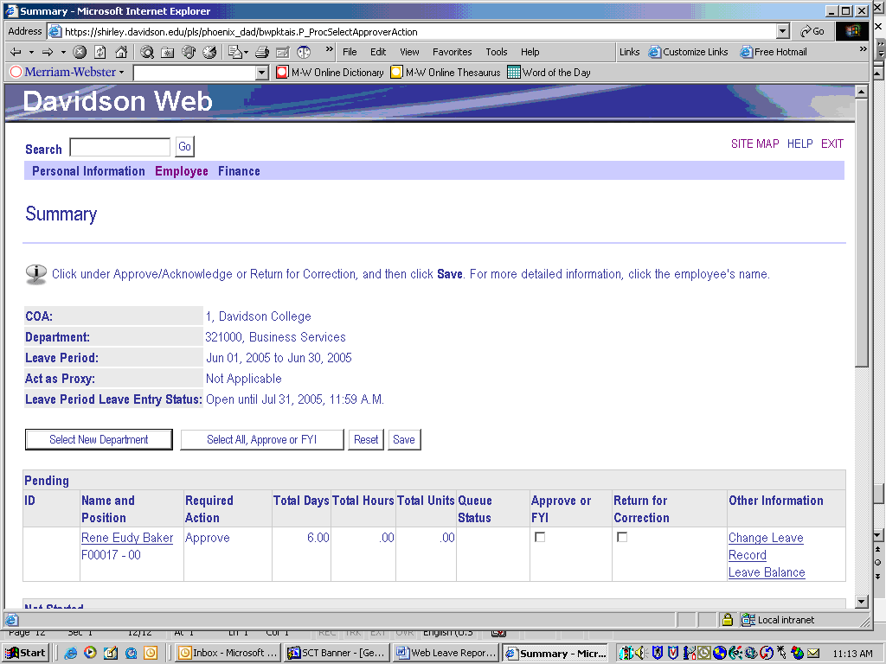
After clicking the employee’s name, you will see the detail of days entered and/or comments.
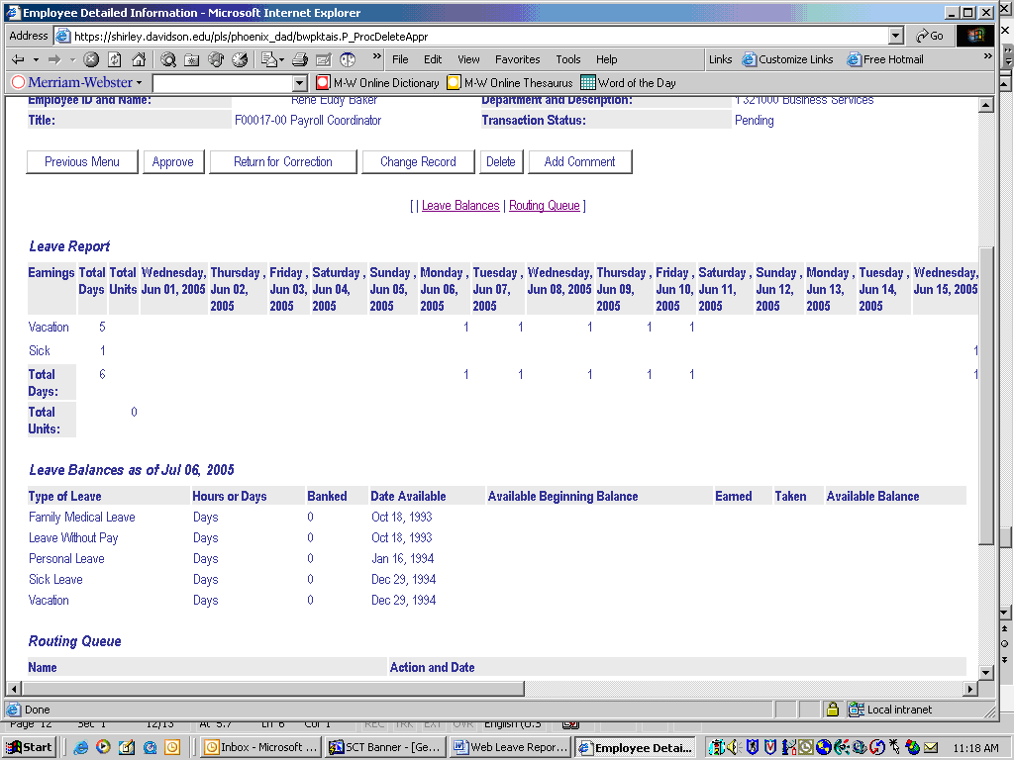

The employee’s time can be approved from the detail screen by clicking Approve
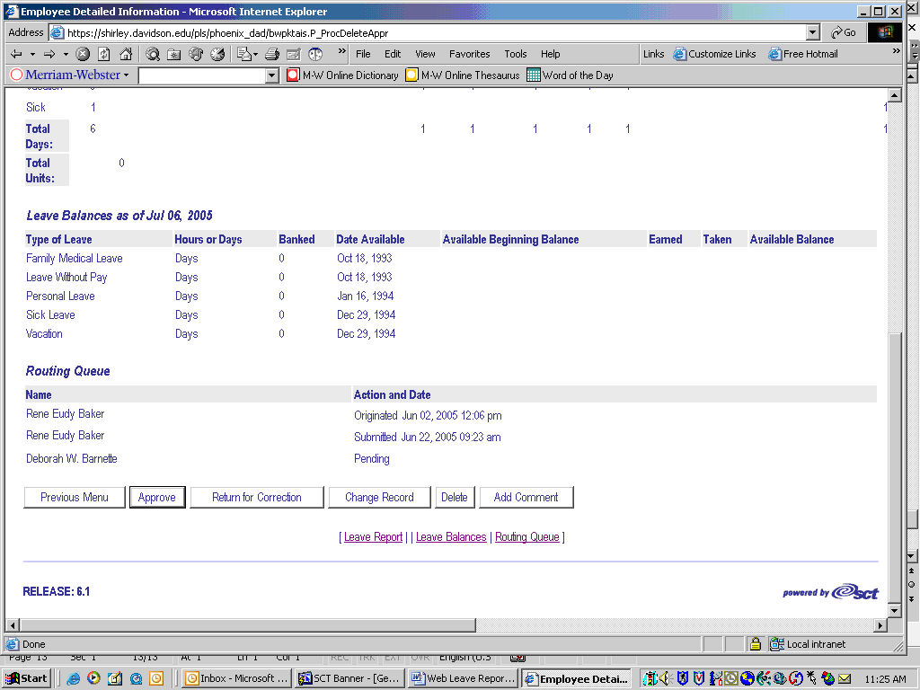

Once approved, the employee’s leave balances are automatically updated.
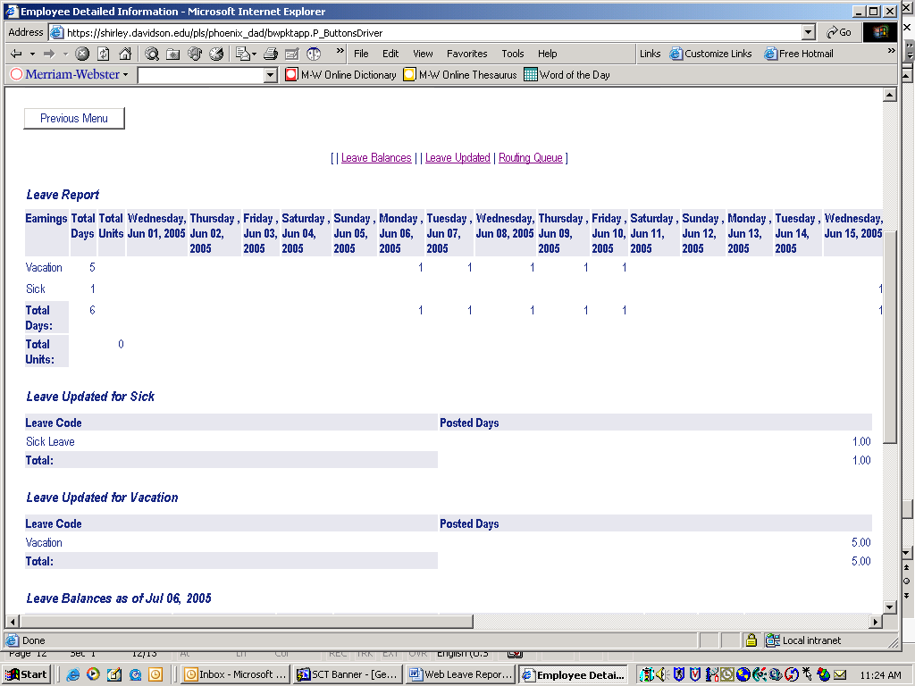

If you have multiple employees’ time to approve, click the ‘Next’ button to advance to the detailed information for the next employee. Once all time has been approved, please logout by clicking ‘EXIT’ in the upper right corner prior to closing browser.

